**COLLAGE BUSINESS EDUCATION**

**DODOMA COMPAS**

**DEPARTMENT OF INFORMATION AND COMMUNICATION TECHNOLOGY**

**OF BACHELOR DEGREE IN INFORMATION TECHNOLOGY (BIT)**

**LECTURES NAME: ATUPELE CAIRO**

**STUDENT NAME: MWANAHAMISI MZAMILU**

**REGISTRATION NUMBER: 03.8756.01.02.2023**

**COURSE NAME :BIT2**

**NAME OF THE PROJECT: REPORT FOR CAR PARKING MANAGEMENT SYSTEM**

**SUBMISSION DATE: JAN/28/2025**

**REPORT FOR MONAH CAR PARKING MANAGEMENT SYSTEM**

**introduction**

A car parking management system is a software and hardware solution designed to streamline and optimize the parking experience for both vehicle owners and parking facility operators.

[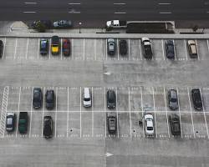](https://sensordynamics.com.au/what-are-the-key-features-of-a-parking-management-system/)

Car parking management system

These systems typically incorporate a range of technologies, including:

* **Sensors:** To detect vehicle presence and occupancy in parking spaces.
* **Cameras:** For vehicle recognition and monitoring.
* **Automatic Number Plate Recognition (ANPR):** To capture and process license plate information.
* **Payment Gateways:** To enable cashless transactions and automated fee collection.
* **Software:** To manage access control, generate reports, and provide real-time information.

Key benefits 0r 0bjectives of car parking management systems include:

* **Increased efficiency:** By automating tasks and optimizing space utilization.
* **Enhanced security:** Through vehicle monitoring and access control.
* **Improved customer experience:** By providing convenient payment options and real-time information on parking availability.
* **Revenue generation:** By enabling flexible pricing models and reducing revenue leakage.
* **Data-driven insights:** By providing valuable data on parking usage patterns and trends.

Car parking management systems are used in a variety of settings, including:

* **Off-street parking lots and garages:** In residential, commercial, and public spaces.
* **On-street parking:** For managing metered and permit parking.
* **Transportation hubs:** Such as airports and train stations.
* **Event venues:** To manage parking for large gatherings.

Car parking management in Tanzania faces several significant challenges:

* **Inadequate Parking Infrastructure:**
  + **Limited Supply:** Insufficient parking spaces in urban areas, especially in densely populated cities like Dar es Salaam, leading to severe congestion and difficulties in finding parking.
  + **Poorly Planned Parking Facilities:** Existing parking lots are often poorly designed, with limited accessibility, inadequate lighting, and lack of security measures.
* **Lack of Enforcement and Regulation:**
  + **Weak Enforcement of Parking Rules:** Limited enforcement of parking regulations, such as time limits, designated parking zones, and no-parking areas, leading to haphazard and obstructive parking.
  + **Lack of Clear Regulations:** Ambiguous or outdated parking regulations contribute to confusion and difficulty in enforcing rules effectively.
* **Technological Limitations:**
  + **Limited Use of Technology:** Inadequate utilization of modern technologies like smart parking systems, mobile apps, and real-time parking guidance systems to optimize parking utilization and improve efficiency.
  + **Lack of Data Collection and Analysis:** Insufficient data collection and analysis on parking demand and supply, hindering effective planning and decision-making.
* **Social and Economic Factors:**
  + **Rapid Urbanization:** Rapid population growth and urbanization in Tanzanian cities exacerbate the parking problem due to increased vehicle ownership and limited land availability.
  + **Economic Constraints:** Limited resources and budget constraints hinder the development and maintenance of adequate parking infrastructure.
* **Environmental Concerns:**
  + **Traffic Congestion:** Inadequate parking leads to increased traffic congestion, contributing to air pollution and noise pollution.
  + **Environmental Impact:** Uncontrolled parking can lead to environmental degradation and damage to public spaces.

These challenges significantly impact the daily lives of residents and businesses in Tanzania, leading to traffic congestion, wasted time, and economic losses. Addressing these issues requires a multi-pronged approach involving improved planning, effective enforcement, technological advancements, and increased public awareness.

To eliminate that problem as a programmer I came up with the car parking management system that will manage and solve the problem above

Here is the management basement assuming you are in a car parking with name Monah carparking and title image the carparking contains 3 classes namely executive,V.I.P class ,regular class each with 10 slots the car parking charges 10000,5000,2000 according to class respectively but additional time is also charged as follows less than 15 minutes you will be charge 25% of the cost at a specific class, less than 30 minutes you will be charge 50% of the cost at a specific class, less than 45 minutes you will be charge 75% of the cost at a specific class. also we offer snacks and drinks for every customers regardless the class and optional car washing here only executive class cars will be washed for free, V.I.P class cars will be charged 2500,regular class will be charged 5000,in order to calculate the time of car parked the car arrival time and departure time should be known

The car parking need a very unique management system in order to regulate the car parking services efficiently as the system requires

>arrival time

>departure time

>total time the car was parked

>total cost for the time parked

>requires to know if an individual is to be provided any special offer

>and to print the receipt of each customer

There for by using the concept of Java swing,Jpannel,Jlabel and other components I was able to make the management possible

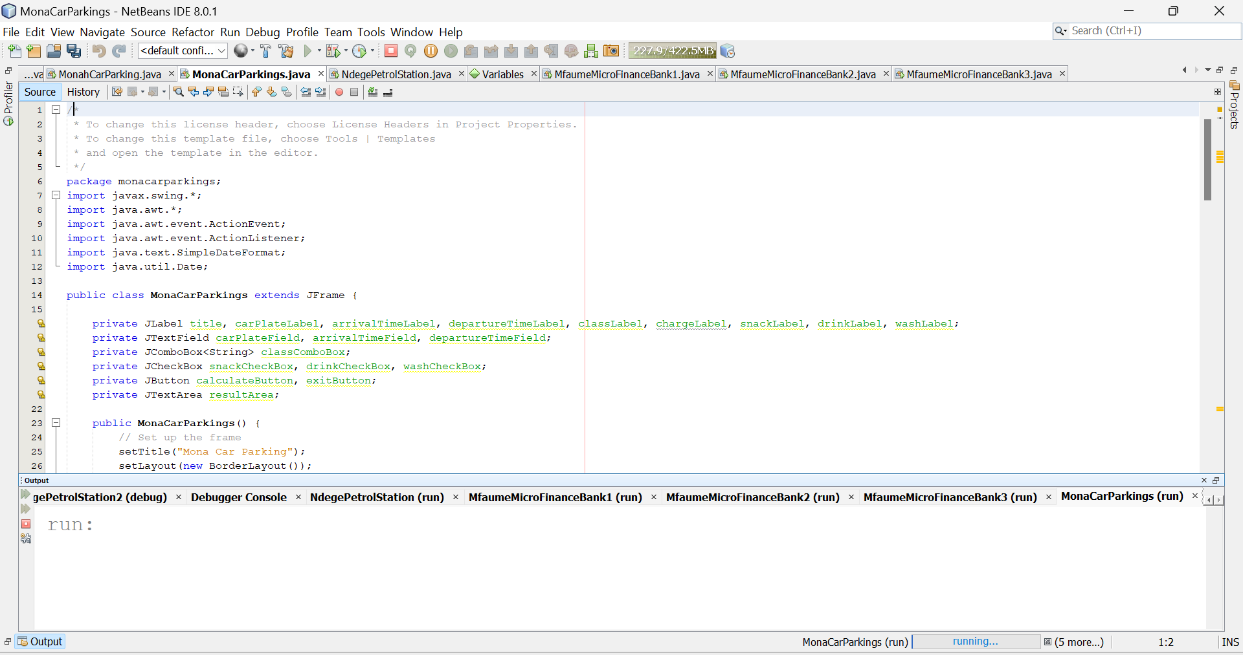

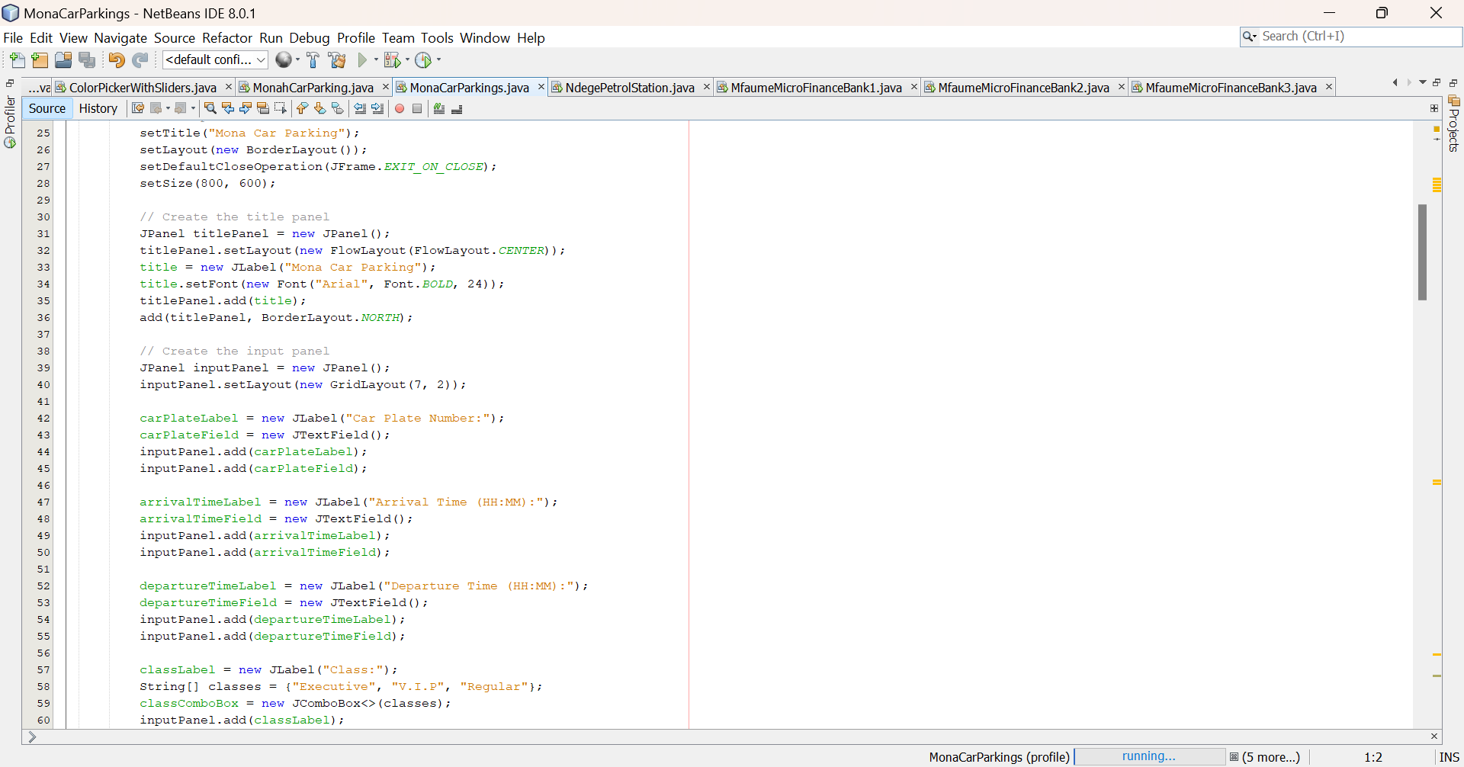

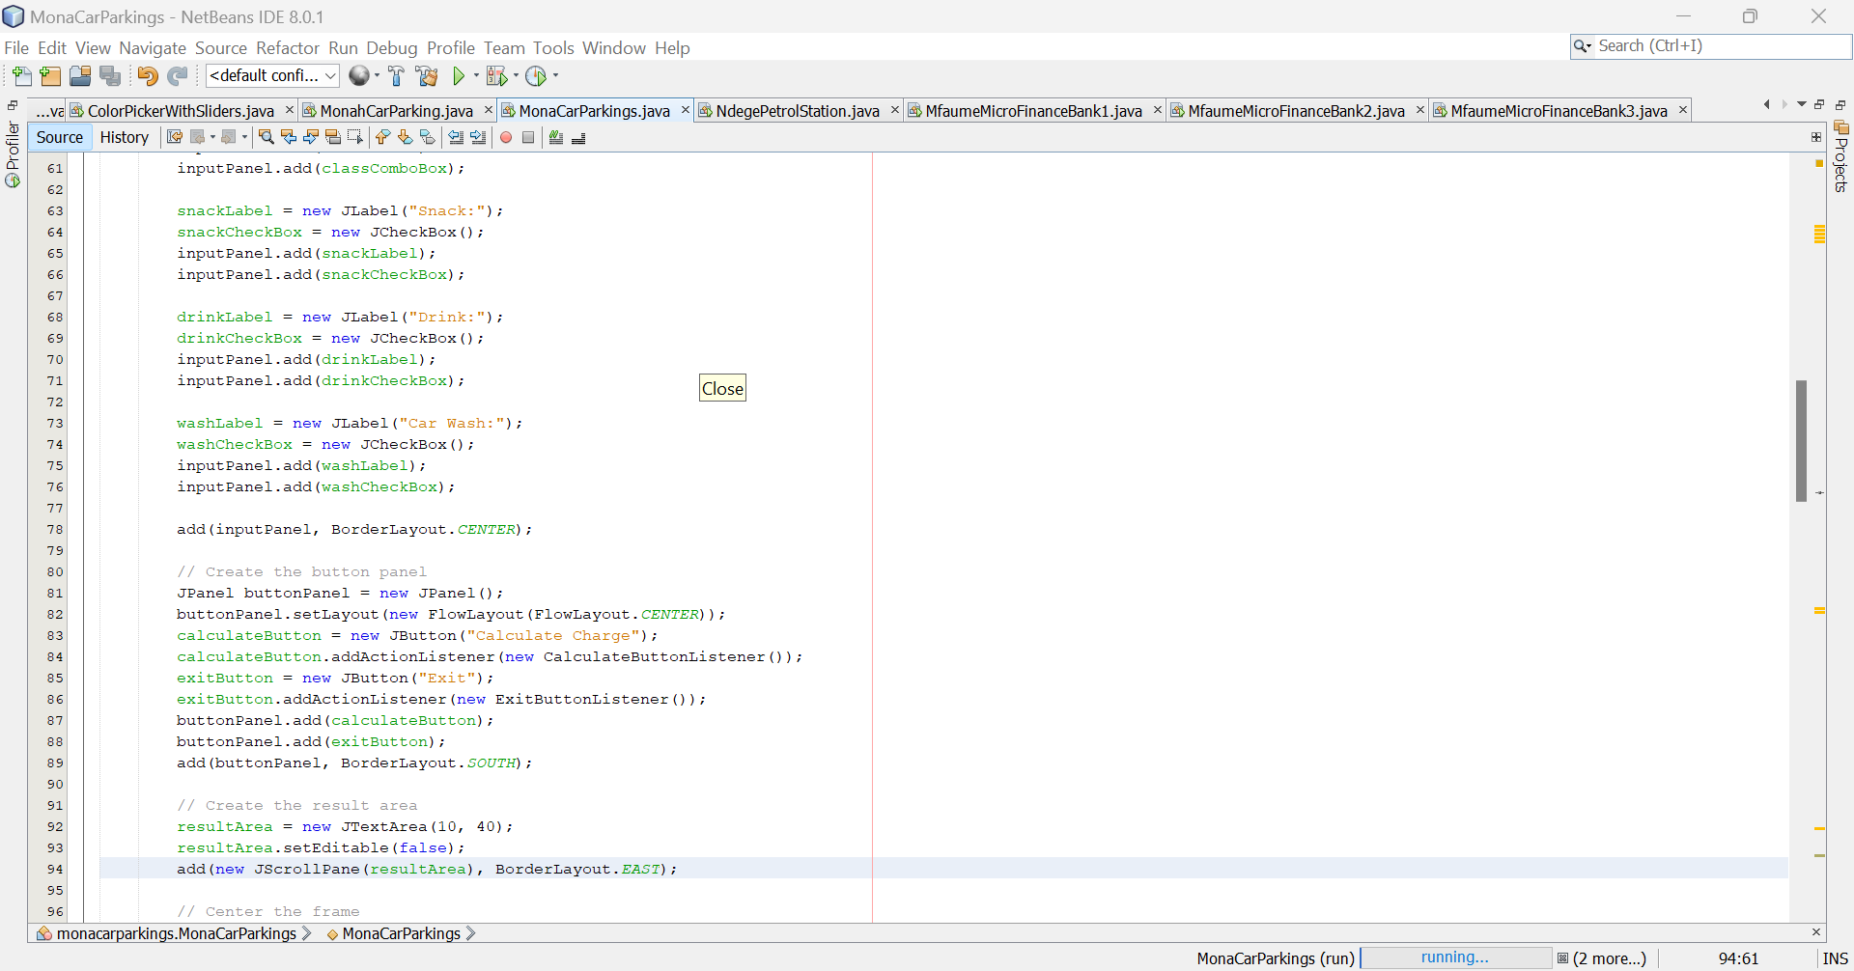

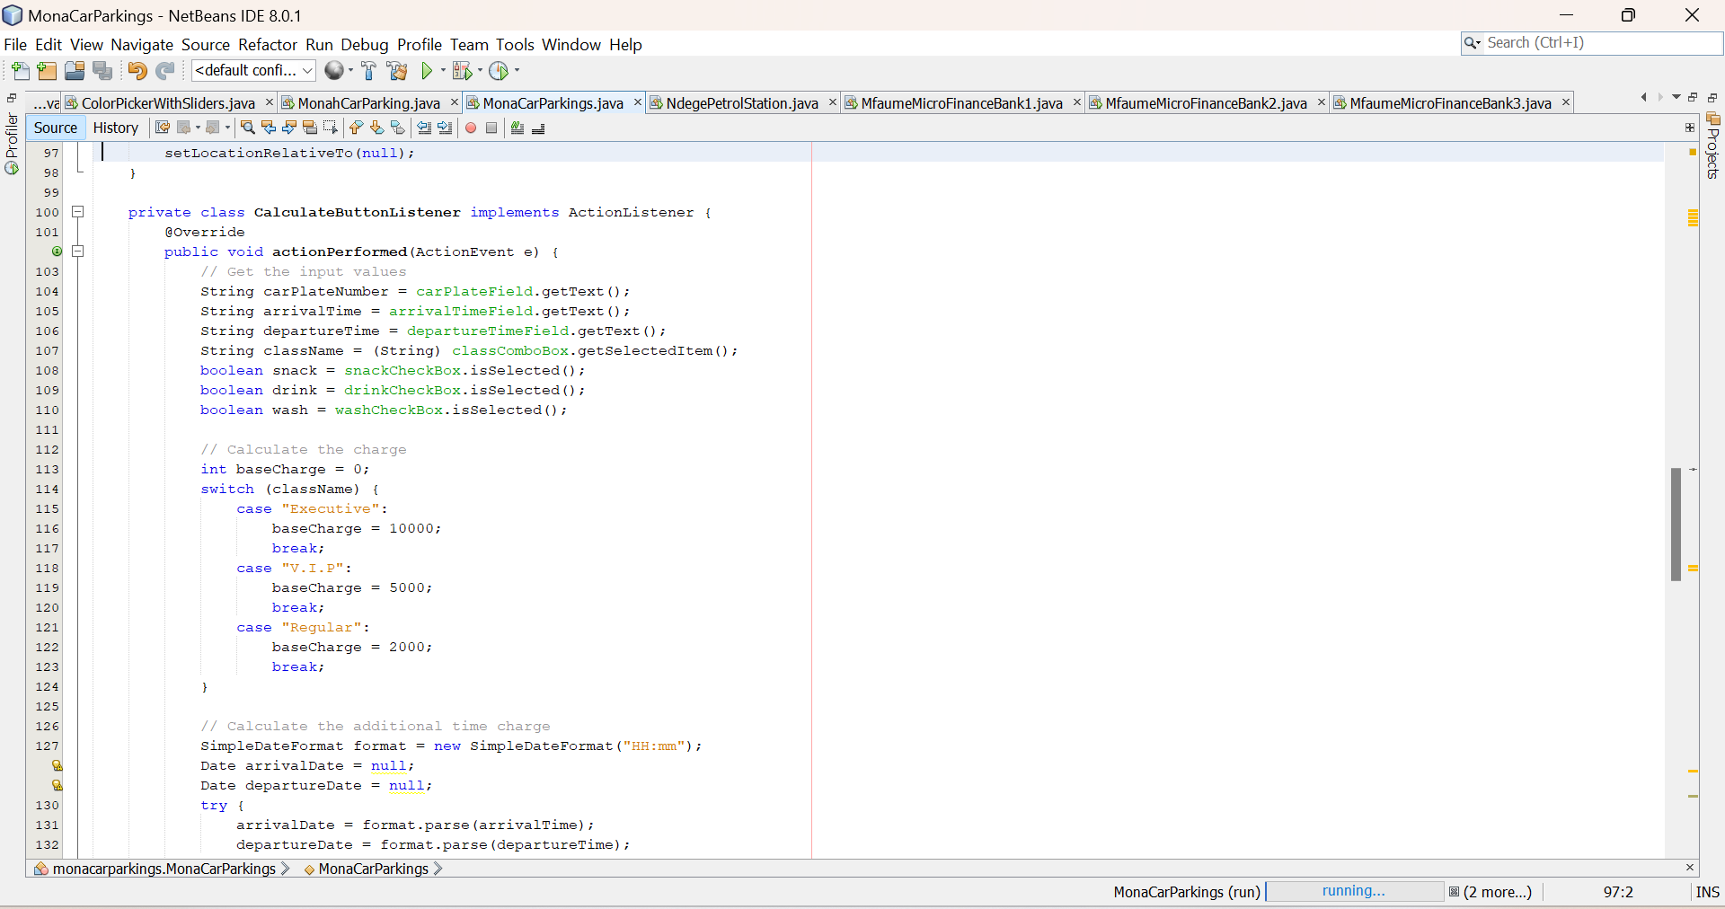

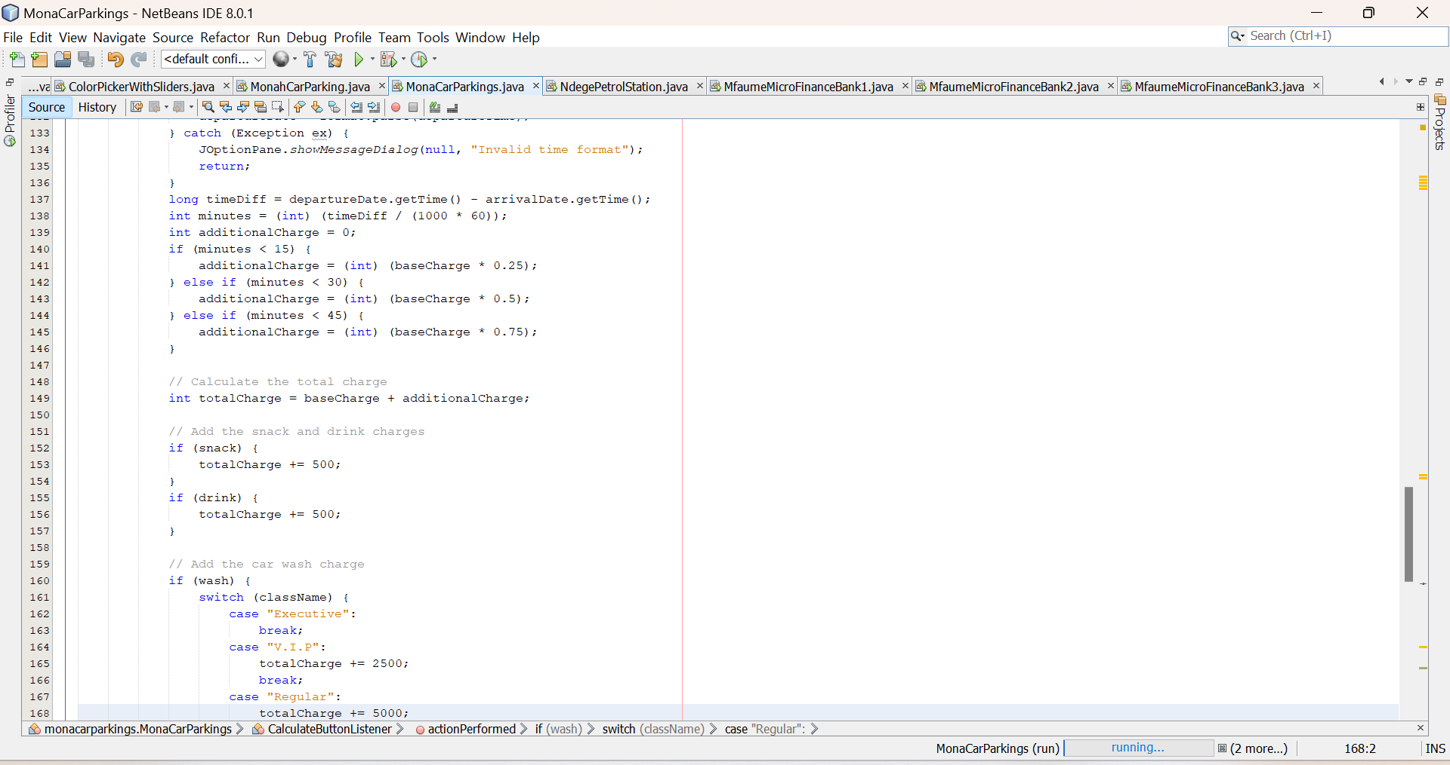

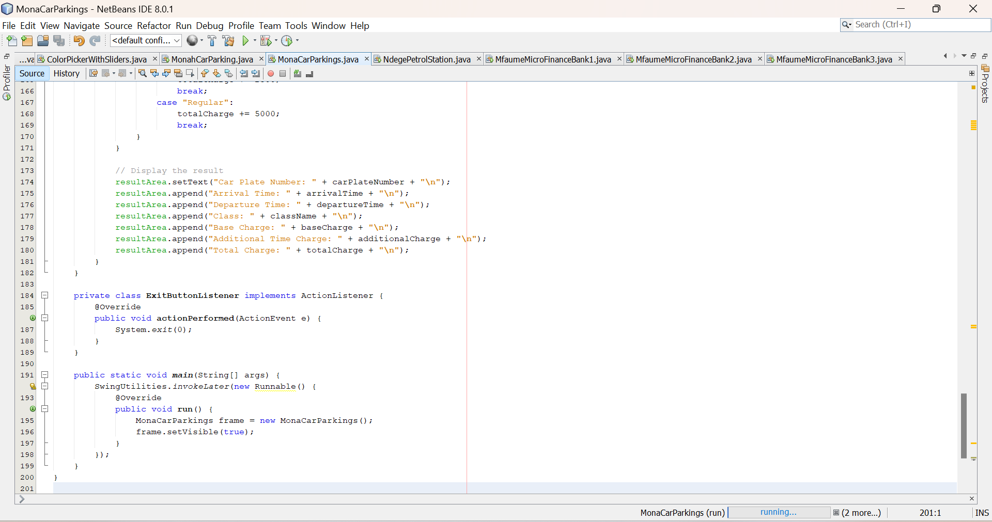

The codes generated were successful runed an they produced out comes that were clear and very efficient for the uses in any carparking management organization not only monah carparking .

The following were the the final out comes of the java program I was working on (Monah carparking) as illustrated below

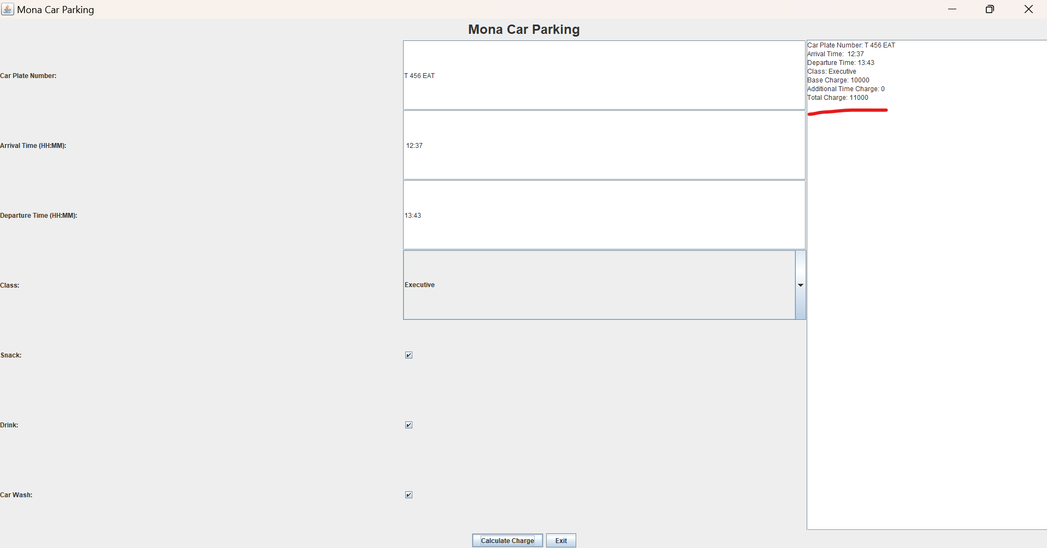

Fig showing the outcome of the of the java application,after running it and showing calculated price and time parked car plate umber and the underlined part shows the printed receipt

Advantages of the program

Developing a Java program for car wash management offers several potential benefits, such as:

* **Increased Efficiency:** Automating tasks like appointment scheduling, inventory tracking, and customer records can streamline operations and reduce manual labor.
* **Improved Customer Service:** A well-designed system can enhance customer experience through features like online booking, personalized offers, and loyalty programs.
* **Better Inventory Management:** Tracking supplies, monitoring usage, and generating reports can optimize inventory levels and minimize waste.
* **Enhanced Financial Tracking:** The program can facilitate accurate invoicing, track sales, analyze profitability, and generate financial reports.
* **Data-Driven Decision Making:** The system can provide valuable insights into customer behavior, popular services, and peak hours, enabling data-driven decisions to improve business strategies.

However, there are also potential disadvantages to consider:

* **Development Costs:** Developing and maintaining a custom Java application can involve significant time and financial investment.
* **Complexity:** Implementing a comprehensive car wash management system can be complex and may require specialized Java programming skills.
* **Maintenance:** Ongoing maintenance, including software updates, bug fixes, and security patches, is necessary to ensure the system's functionality and reliability.
* **Integration Challenges:** Integrating the system with existing hardware and software (e.g., point-of-sale systems, payment gateways) may present challenges.
* **Potential for Errors:** As with any software system, there's always a risk of bugs or errors that could disrupt operations if not properly addresses.

**REFERENCES**

**.Google Scholar:** A powerful search engine for scholarly literature, allowing you to find research papers, articles, and conference proceedings related to car parking management systems.

• **IEEE Transactions on Intelligent Transportation Systems:** A leading journal for research on intelligent transportation systems, including smart parking.

• **Transportation Research Part C: Emerging Technologies:** Focuses on emerging technologies in transportation, such as intelligent transportation systems and smart parking.

• **IEEE Intelligent Vehicles Symposium:** An international conference on intelligent vehicles, covering topics such as vehicle-to-vehicle communication, autonomous driving, and smart parking systems